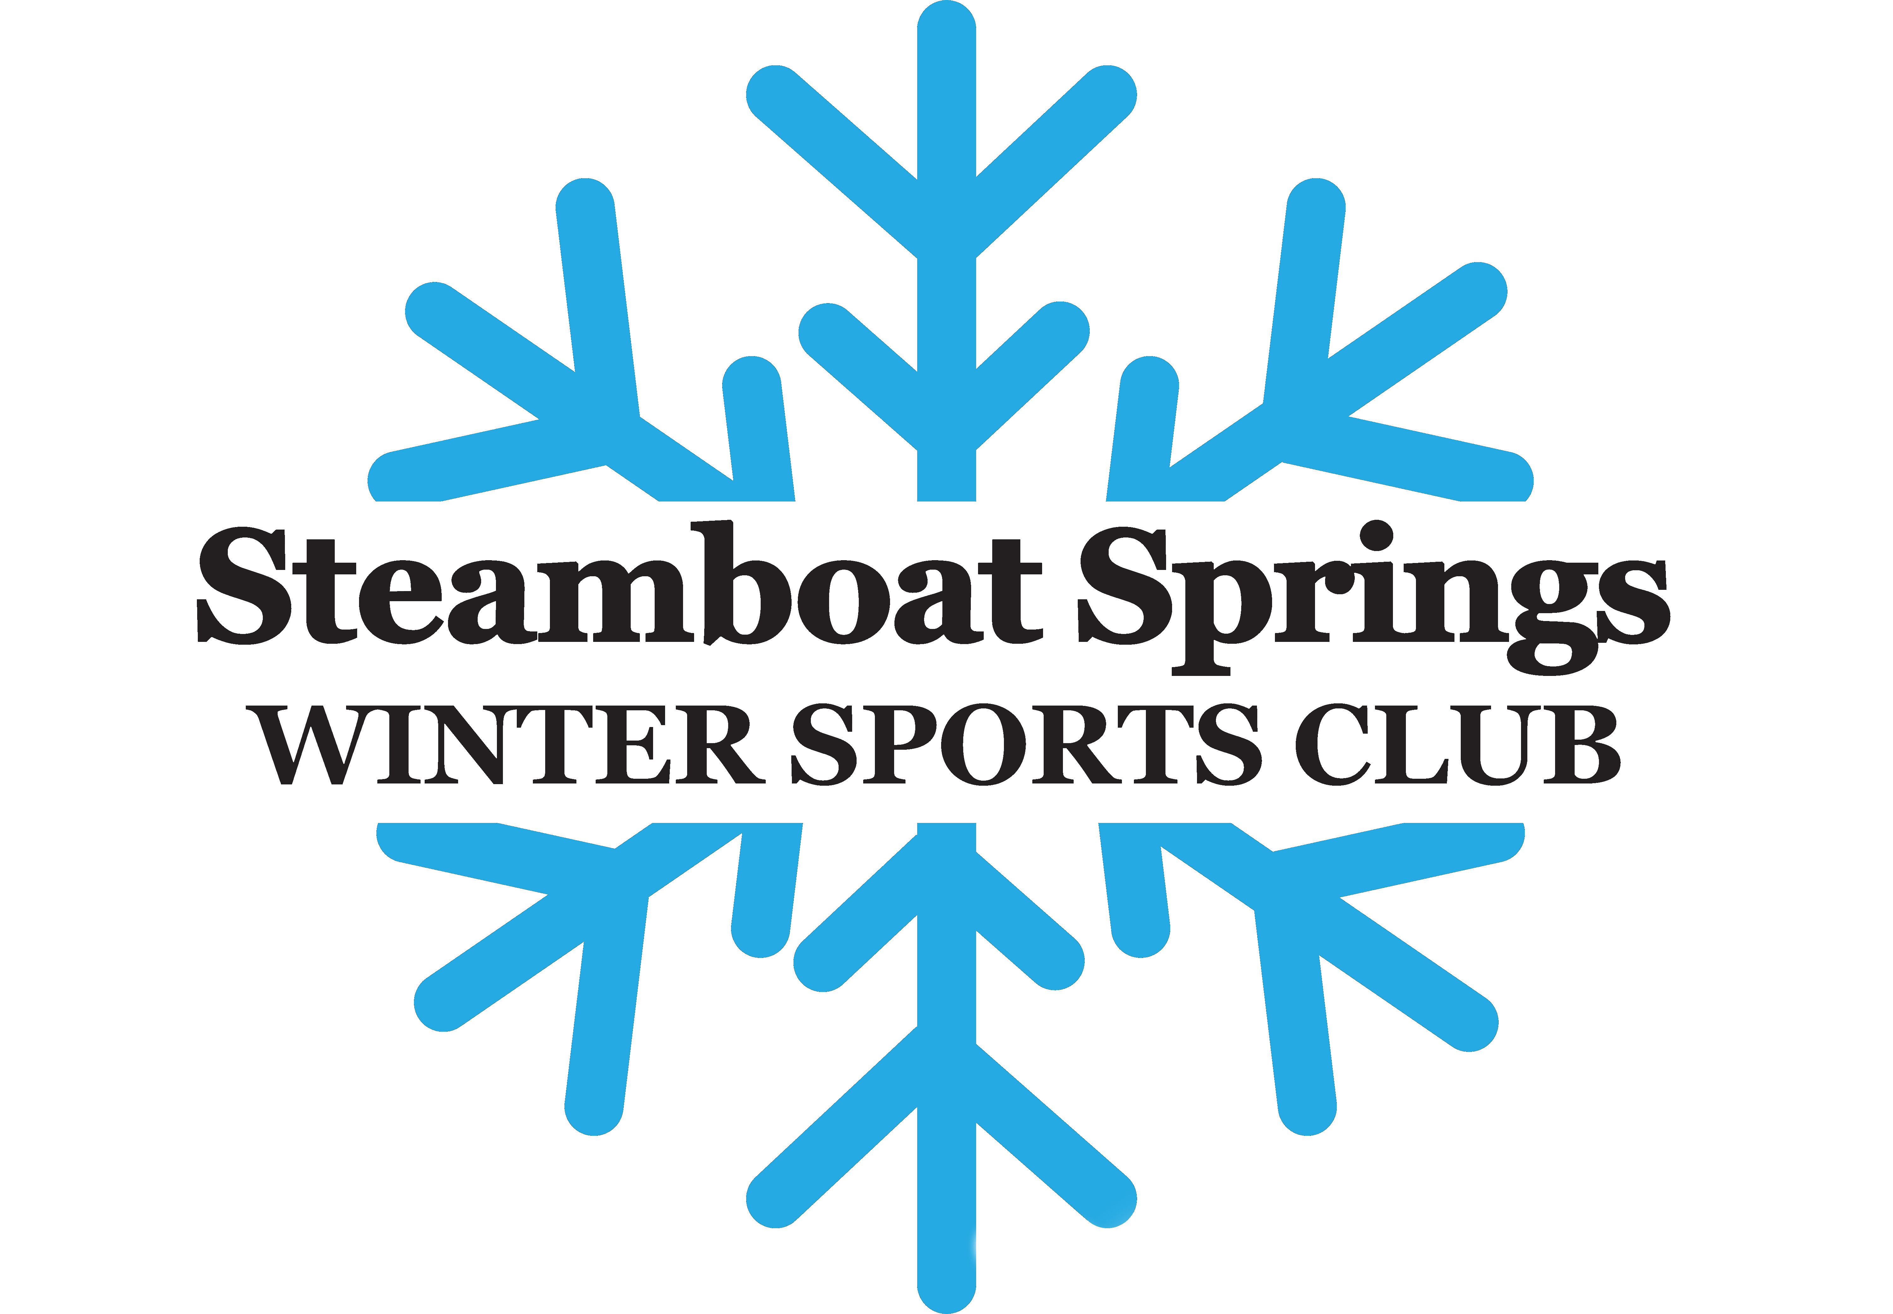

Steamboat Springs Winter Sports Club
Job Description

Position: SSWSC U10/U12 Coach

Physical Requirements
- Must be in reasonable physical condition to engage in outdoor athletic activities for 8 hours.
- Must be able to lift 50lbs on a regular basis.
- Must be able to ski comfortably in all conditions with proper form and technique.

Minimum Skills, Experience, and Ability
- Must possess excellent relationship and communication skills, to work closely with other coaches/parents/athletes and community partners.
- Strong team player, good sense of humor and ability to keep focus of job in perspective while being patient, caring and supportive of each athlete.
- Must enjoy working in and around young athletes and be responsible for their safety and well-being.
- Must coach on Alpine ski set-up (heel must be locked)
- USSA Level 100 highly encouraged or PSIA level 2 or above.
- Must maintain current US Ski and Snowboard membership.

Specific Duties and Responsibilities
- Coaching commitment can range from 3 -6 days/week.
- Primary area of responsibility as a U10/U12 Coach is to create, develop, enhance, and follow all aspects of the U10/U12 program, a fundamental skill based alpine ski program and entry race program.
- Complete all required USSA license and online training.
- Attend SSWSC staff/coach training throughout the season.
- Establish and maintain regular communication and relationships with all parents in your group. Send bi-monthly communication to parents.
- Uphold and contribute to the SSWSC mission, vision, and core values.
- Collaborate with Head U10/U12 Coach and/or Youth Director regarding goal for each session, end of season evaluations of athletes.
- Maintain a positive relationship with Steamboat Ski and Resort Corp, Howelsen Hill and all the associated employees.
- Must be on time (15 minutes before meeting time) and not be absent for more than two days throughout the season.
- Is responsible to obtain a qualified sub to cover missed sessions.

Employment Period: October – March

Compensation and Benefits
Salary range: $3500 – 8000 depending on level of commitment and experience.
Benefits:
- Steamboat Ski Resort and Howelsen Hill season ski pass.
- Access to seasonal workouts and gym facilities.
- Coach training and USSS certification options.

Contact: Blair Seymour bseymour@sswsc.org

